Realizable Accessibility: Evaluating the Reliability of Public Transit Accessibility using High-resolution Real-time Data

Luyu Liu 1, Adam Porr 1, Harvey J. Miller 1, *[1]

1 Department of Geography and Center for Urban and Regional Analysis, The Ohio State University, Columbus, OH, USA

The widespread availability of high spatial and temporal resolution public transit data is improving the measurement and analysis of public transit-based accessibility to crucial community resources such as jobs and healthcare. A common approach is leveraging transit route and schedule data published by transit agencies. However, this often results in accessibility overestimations due to endemic delays due to traffic and incidents in bus systems. Retrospective accessibility measures calculated using real-time bus location data attempt to reduce overestimation by capturing the actual performance of the transit system. These measures also overestimate accessibility since they assume that riders had perfect information on systems operations as they occurred. In this paper, we introduce *realizable real-time accessibility* based on space-time prisms (STP) as a more conservative and realistic measure. We moreover define *accessibility unreliability* to measure overestimation of schedule-based and retrospective accessibility measures. Using high-resolution General Transit Feed Specification (GTFS) Realtime data, we conduct a case study in the Central Ohio Transit Authority (COTA) bus system in Columbus, Ohio, USA. Our results prove that realizable accessibility is the most conservative of the three accessibility measures. We also explore the spatial and temporal patterns in the unreliability of both traditional measures. These patterns are consistent with prior findings of the spatial and temporal patterns of bus delays and risk of missing transfers. Realizable accessibility is a more practical, conservative, and robust measure to guide transit planning.

Keywords: accessibility unreliability; GTFS; Space-time prism; schedule-based accessibility; retrospective real-time accessibility; realizable real-time accessibility.

1. Introduction

Accessibility, or the ability to reach opportunities in an environment, is a fundamental concept in transportation science and human geography (Hansen, 1959; Ingram, 1971). As the focus of transportation planning shifts to a sustainable mobility paradigm (Banister, 2008), accessibility measures are becoming more crucial as a performance measure to guide policy, planning and decision-making. Advances in mobility and geospatial data technologies and science have enhanced the sophistication and practicality of accessibility measures to a point that they are transforming planning and policy (Handy, 2020; Levinson & Wu, 2020; H. Wu & Levinson, 2020). This includes the *space-time prism* (STP): a core concept in time geography that models accessibility as the envelope of all possible paths with respect to time based on anchoring locations and times, maximum speeds for travel and stationary activity times (Hägerstrand, 1970). New mobility and geospatial data technologies has allowed researchers to greatly increase the analytical power of this basic time geographic concept (Miller, 2017; Neutens, Witlox, & Demaeyer, 2007).

O’Sullivan, Morrison, & Shearer (2000) pioneered the application of STPs to model public transit accessibility. Since that time, the availability of data on public transit networks and related supporting infrastructure such as sidewalks afforded the development of public transit network accessibility analysis based on high resolution representation of transit and walking networks. However, this research traditionally still depended on assumptions of average schedule frequency and headways during peak and off-peak times (Tribby & Zandbergen, 2012). This barrier has been shattered by the development of data standards for publishing high resolution schedule and real-time vehicle location data public transit data via the General Transit Feed Specification (GTFS) developed by Google. GTFS allows developers to create navigation apps to support public transit users. It is also allowing researchers to analyze the accessibility generated by public transit systems at high levels of spatial and temporal resolution (Lee & Miller, 2018; Wessel, Allen, & Farber, 2017; Wessel & Farber, 2019).

Transit systems are highly dynamic and time-dependent due to variations in operating conditions, and actual performance can be different from the schedule (Park, Mount, Liu, Xiao, & Miller, 2020). There are several factors that contribute to these deviations from scheduled service: first, many bus systems operate within road networks that are shared with other vehicles. Conditions such as recurrent congestion and non-recurrent disruptions like construction and crashes can slow transit vehicles, leading to deviations from the schedule service. Second, only travel time at designated timepoint benchmark stops is explicitly defined in the official timetables of many transit systems; travel time at non-timepoint stops is derived from interpolation, which may not be strictly followed in practice.

Wessel, Allen, & Farber (2017) and Wessel & Farber (2019) compared accessibility measures based on public transit schedule data with accessibility measures calculated retrospectively from real-time vehicle location data, finding substantial differences that call into question the use of schedule data alone for public transit accessibility analysis. However, while retrospective real-time accessibility measures recognize that actual operations can deviate from scheduled service, they assume users know *a priori* the actual arrival time of vehicles (Wessel & Farber, 2019); this knowledge is only attainable after the event happens. This makes accessibility measures calculated retrospectively from real-time vehicle location data unrealistic in depicting the accessibility realized by the transit system and experienced by public transit users.

This paper provides a scalable time geography approach to measure the reliability of transit accessibility. We introduce the concept of *realizable real-time accessibility* based on the STP to address the overestimation of accessibility in traditional measures. Like retrospective real-time accessibility, the realizable real-time accessibility is also calculated based on actual bus locations data, but it acknowledges that users are not able to know the actual arrival times *a priori* and respond in real-time to on-time performance deviations in the network. We also introduce the concept of *accessibility unreliability* as a measure of the deviation of schedule accessibility or retrospective accessibility from realizable accessibility. This measure represents the difference between the expected potential path area (PPA) – i.e., the spatial footprint of the STP – and the actual or realized PPA based on realistic system performance given the same time budget and departure time. The aggregate version of this measure can also show the consistency and reliability of the transit service; this is vital for administrative and planning purposes. We use schedule and real-time vehicle location data to calculate and compare STPs based on schedule, retrospective, and realizable real-time accessibility assumptions. We illustrate these measures using GTFS data from the Central Ohio Transit Authority (COTA) bus system, a public transit agency in Columbus, Ohio, USA. The analyses focus on the spatial and temporal patterns in different levels from 2018 -2019 across Columbus.

In the next section of the paper, we discuss the background of the space-time prism, transit accessibility, and the unreliability issue of accessibility measures. We then introduce the data source; the time-dependent routing algorithm; the concepts of scheduled, retrospective real-time, and realizable real-time STP; and accessibility unreliability in the methodology section. We finally discuss the findings of overall distinction, spatial, and temporal analyses in the results section.

1. Background

This section provides background for the concepts and measures of realizable real-time accessibility and accessibility unreliability. We discuss: 1) the evolution of the space-time prism; 2) the development of transit accessibility measurements; and 3) the unreliability of schedule-based accessibility measures.

* 1. The evolution of the space-time prism

The space-time prism (STP) is a well-established time geography method to measure physical accessibility afforded by transportation systems (Miller, 1991; Y.-H. Wu & Miller, 2001). Since its introduction by Hägerstrand (1970) as a concept, there has been progress in STP analytics based on improving capabilities of computer hardware and software, and the availability of data, allowing the STP to be operationalized and measured more realistically. Lenntorp (1976) provided the first operational implementation of the STP in his computer simulation of possible activity and travel schedules. Burns (1980) provided an analytical foundation for the STP in his formal analysis of the impacts of time, speed, and network changes on accessibility. The rising popularity of geographic information system (GIS) software inspired Miller (1991) to develop a generic GIS-based procedure to derive STPs within transportation networks. Refinements in capabilities for calculating shortest paths from and to arbitrary locations within networks allowed Miller (1999) to refine the STP within transportation networks. Increasing availability of dynamic network data allowed researchers to develop procedures for calculating STPs within networks with time-varying flows and travel times (Y.-H. Wu & Miller, 2001).

Improvements in location-aware technologies such as the global positioning system (GPS), automated vehicle location (AVL) devices and mobile telephony has also allowed greater refinement and wider application of the STP. Abundant data help refine STP models and enhance the reliability of STP measures. For example, Chen et al. (2013) used floating-taxi traffic data to introduce travel time uncertainty into the calculation of STP, better capturing traveler’s stochasticity. Delafontaine, Neutens, & Van de Weghe (2011) introduced a STP framework with emphasis on travel time uncertainty in nonnetwork-constrained environments. Scalability of STP also becomes a new research focus due to emerging spatiotemporal big data. For example, Chen et al (2016) proposed a scalable and efficient spatiotemporal data model to address the high-volume and high-diversity challenges. Abundant data also help extend the applicability of STP and time geographic models to wider domains. For example, Fang, Shaw, Tu, Li, & Li (2012) utilized STP to identify crucial links from a large origin-destination trips dataset. Farber, O’Kelly, Miller, & Neutens (2015) used social interaction potential and space-time prism to measure the spatial and temporal dynamics of social segregation. Li & Farber (2016) used social interaction potential to explore the role of modifiable areal unit problem in time geographic accessibility measures. Widener, Farber, Neutens, & Horne (2015) used social interaction potential to measure and compare food access by automobile and public transit. More diverse and available big data sources support greater refinement and broader application of the STP models.

* 1. The evolution of transit accessibility measurement

Malekzadeh & Chung (2020) suggest there are two major trends for transit accessibility studies: i) capturing travelers’ behavior; ii) developing more disaggregated transit accessibility measurements. Both trends exemplify how larger, more detailed, and more accessible datasets impact the formulation of transit accessibility models.

Due to its multimodal and nonlinear nature, early transit accessibility models usually adopt simple assumptions based on travel time estimations, which significantly reduces their computational burden (Malekzadeh & Chung, 2020). For example, some early transit accessibility models consider the proximity to transit stops by only walking as the accessibility to a transit system (Hsiao, Lu, Sterling, & Weatherford, 1997; Zhao, Chow, Li, Ubaka, & Gan, 2003), which is a major simplification since they ignore the travel time in the transit system. As transit-related datasets become more detailed and accessible, models can better capture the travelers’ behavior, such as system-facilitated models – i.e., measuring users’ ability to reach other opportunities in the transit network (Tribby & Zandbergen, 2012) and integral accessibility models – i.e., measuring overall access to a number of possible destination (Farber, Bartholomew, Li, Páez, & Habib, 2014; Owen & Levinson, 2015). As mentioned in the introduction of this paper, O’Sullivan, Morrison, & Shearer (2000) pioneered the application of STPs in the analysis of public transit accessibility. However, their analysis assumes travel though planar space outside the transit network. Tribby & Zandbergen (2012) improved transit accessibility by incorporating detailed representations of the sidewalk network for traveling to, from and between transit stops. However, their analysis assumes a static or steady-state transit headway for peak and off-peak hours, based on scheduled service frequency. More detailed and specific models powered by high-resolution and large-volume real-time data can provide a better understanding of transit accessibility.

Another trend in transit accessibility analysis is more disaggregated transit accessibility measurements. For example, while traditional studies mainly addressed accessibility at the regional level and stop level (O’Sullivan et al., 2000; Tribby & Zandbergen, 2012), recent studies can assess trip-level or even person-level accessibility based on fine-grained standard data like General Transit Feed Specification (GTFS) and smart card data (Arbex & Cunha, 2020; Batty, 2013; Lee & Miller, 2018). These data have well-defined structures for scheduled information, real-time bus location and time, or trip behavioral information; GTFS are also often released publicly by transit authorities (Barbeau & Antrim, 2013). Therefore, many recent studies use GTFS to derive STP in a larger scale without compromising the fine details of transit systems (Lee & Miller, 2018; Tasic, Zhou, & Zlatkovic, 2014). Larger and more-detailed datasets, greater computational ability, and better visualization methods help to improve the fidelity and granularity of transit accessibility analysis.

* 1. Unreliability of schedule-based accessibility measures

As recent studies focus more on capturing users’ stochasticity, unreliability becomes the center of the discussion: in other words, how well can an accessibility measurement capture the actual experience of a user in the system? We define unreliability as an accessibility measurement’s deviation from a standard benchmark, which ideally should represent the accessibility delivered to or experienced by users. Due to the lack of accessible real-time data sources, most traditional accessibility measures are calculated based on transit schedules (Wessel & Farber, 2019); therefore, many schedule-based accessibility measures can be unreliable due to two factors: *uncertainty* and *accuracy*.

*Uncertainty* refers to the stochastic variation of the accessibility measure, due to on-time performance and measurement error. Public transit systems are constantly changing, with early or late arrival times occurring because of unexpected external or internal factors, such as traffic, weather, vehicle conditions, or operator conditions. Hall (1983) was among the first to consider uncertainty when formulating and calculating accessibility. Similar to the development of STP, more studies are being dedicated to discussing the unreliability of accessibility measures with better datasets. For example, Kim & Song (2018) discuss an integrated measure of accessibility and reliability for transit systems; Zhang, Dong, Zeng, & Li (2018) introduce a time-dependent reliability modelling approach based on GPS trajectories to address traditional measures’ overestimation problem.

Another factor that can contribute to a schedule-based accessibility measure’s unreliability is *accuracy*. It can be defined as systematic deviations of an accessibility measure from the standard benchmark. Some papers discussed the topic with empirical evidence: Wessel et al. (2017) constructed a retrospective transit timetable from real-time automatic vehicle location data to better capture the dynamic nature of transit system. The paper also provided a case study for the Toronto Transit system and pointed out that an accessibility measure based on retrospectively collected real-time vehicle locations data does have significant deviation from the scheduled, and the pattern of the deviation does not seem random. Wessel & Farber (2019) moreover explored the accuracy of schedule-based accessibility in Toronto, Jacksonville, Massachusetts Bay, and San Francisco. The paper concludes that schedule-based accessibility measures overestimate on average by 5 to 15 percent or more, and it may not be sufficient to use schedule data alone to evaluate transit accessibility for most transit systems.

Traditional schedule-based accessibility measures have both uncertainty and accuracy issues. In the following sections, we continue the discussion of schedule-based unreliability issues; we also expand the discussion to examine unreliability issues in retrospective accessibility measures.

1. Methodology

In this section we introduce the definition of accessibility and unreliability. We first introduce the two main transit datasets on which our analysis is based. Then, we demonstrate a time-dependent Dijkstra algorithm to calculate the two versions of space-time prisms.

* 1. Data sources

We use General Transit Feed Specification (GTFS) data as the main data source for time geography analyses in this paper. GTFS is a data standard that helps transit authorities to publish transit data and developers/researchers to consume the data (Google Developers, 2020). GTFS includes two parts: GTFS static and GTFS real-time data, corresponding to scheduled service and real-time vehicle locations, respectively. Several relational database tables comprise the GTFS static data, specifying the transit system’s stops, trips, routes, arrival and departure time, and other schedule information (Google Developers, 2020). The GTFS real-time data includes two parts: *trip update*, which contains the expected arrival/departure time of each trip at each stop in the transit system, and *vehicle position*, which is similar to automatic vehicle location (AVL) data and shows the location of active vehicle in the system (Google, 2021). Transit authorities broadcast GTFS real-time data at regular time intervals from 10 seconds to 90 seconds to support navigation apps (Liu & Miller, 2020a). We derived the actual arrival time of each trip at each stop from the latest trip update feeds.

We collected both GTFS static and real-time trip update data from the official application programming interface (API) of the Central Ohio Transit Authority (COTA) from February 2018 to March 2020 (Central Ohio Transit Authority, 2021). We record the updated GTFS static data whenever there are any changes in the schedule data. This can include minor changes on a daily basis, three seasonal adjustments in January, May, and September, major planned route and schedule changes, such as COTA transit system redesign in May 2017 (Lee & Miller, 2018; Schmitt, 2018), and COVID-19-related schedule adjustments in 2020 (Liu, Miller, & Scheff, 2020). We collected real-time trip update feeds at the interval of 60 seconds; this is a common GTFS real-time update frequency for US transit systems (Liu & Miller, 2020a). The timespan covers February 2018 to July 2021 and the total data volume exceeds 1 terabyte. Due to the large data size, we used a noSQL (unstructured) database technology, MongoDB, to maintain the database and support queries.

* 1. Time-dependent routing

We use the STP, a well-established time geography method, to measure accessibility in public transit systems (Miller, 1991; Y.-H. Wu & Miller, 2001). In practice, we first calculate the shortest travel time between the origin stop to all other stops in the system. We then derive the STP and its spatial footprint, the PPA, from the shortest travel time.

It can be challenging to obtain accurate travel times in a transit network, even with a complete archive of retrospective arrival times. A major reason is because transit networks are *discontinuous* and *time-dependent* (Gendreau, Ghiani, & Guerriero, 2015; Wang, Yuan, Ma, & Wang, 2019). Unlike private vehicle or pedestrian network, a user cannot move in the network until he or she boards a vehicle which arrive only at specific time points. Therefore, the network costs of transit can vary depending on the passenger’s arrival time at the originating stop of a transit system. This time-dependent variation also applies to other components of public transit travel times, including wait time and in-vehicle time.

There are two approaches to time-dependent routing: deterministic and stochastic (Gendreau et al., 2015). Stochastic models include a random factor to predict the time-varying travel times. They are useful at capturing the randomness caused by congestion, weather, crashes, and road maintenance (Gendreau et al., 2015); however, because we collected the arrival times at all the stops and aim for more precise travel time measures, we use a deterministic approach to address the time-dependent routing problem.

We use a Dijkstra algorithm with dynamic costs to solve the time-dependent routing problem. The Dijkstra algorithm is a classic and efficient algorithm to solve the shortest path routing problem (Golden, 1976). It uses a greedy strategy to find the shortest path from the origin node to every other nodes (Xie, Zhu, Yan, Yuan, & Zhang, 2012), which significantly reduces the size of the subproblems and is very useful and efficient to calculate the STPs. However, the correctness of the Dijkstra algorithm is based on non-negative static costs that time-dependent transit networks do not satisfy. In particular, a vehicle with a later start time may result in an earlier arrival time than another vehicle if the first vehicle *passes* the second (Gendreau et al., 2015). Consequently, the results generated by Dijkstra algorithm with dynamic costs may not be the globally optimal solution. Therefore, many prior studies introduced *no-passing* or *first-in-first-out (FIFO)* rule to make the Dijkstra algorithm compatible with the time-dependent requirements (Ahn & Shin, 1991; Ichoua, Gendreau, & Potvin, 2003). FIFO rule assumes a vehicle leaving an origin stop will never arrive later at the destination stop than another vehicle that departed later. FIFO rule is a prerequisite to use Dijkstra to calculate routing problem in a transit system. Therefore, we tested if vehicles in the COTA system satisfy the FIFO rule by calculating whether each bus in the transit system can indeed pass subsequent buses in the same route. The average proportion of no-passing buses is 95%; therefore, we conclude that there are very few passing occurrences in the COTA system, and the FIFO rule generally applies to the system.

* 1. Three space-time prisms

After calculating the time-dependent shortest travel time between any stops in the system based on the scheduled and retrospective GTFS data, we derive an implicit STP by calculating the number of accessible bus stops. We use a decision variable $δ_{ijτ}^{ϕ}$ to represent whether a user starting from stop $i$ at time point $t$ can arrive at another stop $j$ within the time budget $τ$:

|  |  |  |
| --- | --- | --- |
|  | $$δ_{ijτ}^{ϕ}=\left\{\begin{aligned}1 t_{ij}^{ϕ}≤τ \\ 0 t_{ij}^{ϕ}>τ\end{aligned}\right.$$ | (1) |

where $t_{ij}^{ϕ}$ is the shortest travel time between stop $i$ and $j$ starting from a time point $ϕ$. Therefore, the number of accessible stops with the time budget $τ$ can be written as:

|  |  |  |
| --- | --- | --- |
|  | $$s_{iτ}^{ϕ}=\sum_{j∈S}{δ_{ijτ}^{ϕ}}$$ | (2) |

where $s_{iτ}^{ϕ}$ represents the number of accessible bus stops (or an implicit PPA of the STP) from stop $i$ at the time point $t$ with the time budget $τ$, and $S$ is the set of all stops. We can then introduce the definition of the STP:

|  |  |  |
| --- | --- | --- |
|  |  | (3) |

where $S_{i}^{ϕ}$ represents the implicit STP from stop $i$ at a time point $ϕ$, while $Τ$ is the set of all time budgets.

We produce three versions of the bus stop-based implicit STPs based on the shortest travel times, namely scheduled, retrospective real-time, and realizable real-time STPs.

**Scheduled STP.** Scheduled STPs are calculated based on the scheduled time from the GTFS static dataset. It represents the expected accessibility that a passenger can achieve if the transit system operates perfectly according to the schedule. However, the actual travel time and accessibility may vary due to on-time performance deviations and schedule is not an unbiased representation of a transit system’s actual performance (Park et al., 2020); therefore, the scheduled STP is typically an overestimate of the actual accessibility experienced by a passenger.

**Retrospective real-time STP**. As we can access all the historical arrival times from the GTFS real-time archive, we can calculate a retrospective version of the STP using the same algorithm described above by changing all the scheduled arrival times to corresponding retrospective real-time arrival times (Wessel et al., 2017; Wessel & Farber, 2019). Although this allows for deviation from the schedule STP, it is still idealistic. When planning trips, the user cannot know *a priori* the actual arrival time of each bus (Wessel & Farber, 2019). Although it can be a useful reference for transit agencies and users, the *retrospective real-time STP,* or more generally *retrospective real-time accessibility,* cannot be realized by users. It overestimates users’ accessibility because it assumes users have omniscient knowledge of the transit system, even events that happen in the future. There are some unnatural and infeasible results caused by this overestimation: in the retrospective model, a user can decide to take a very different combination of trips and routes that will not be possible without predicting the future.

For example, Figure 1 shows a real-world routing example based on COTA data that illustrates the overestimation potential for retrospective accessibility to overestimate caused by a preemptive transfer when the receiving bus that the user will transfer to is delayed (Liu & Miller, 2020b). The map shows two retrospective- and schedule-based routes; the retrospective route saves one transfer and much time compared to the scheduled scenario by taking a different bus at the circled stop. This was only possible for the retrospective scenario because the incoming bus in the alternative second leg (route 101, colored pink with origin stop circled) was delayed by four minutes relative to the schedule. However, unless the transit user can predict the future or have perfect real-time information feeds, it is almost impossible to foresee this transfer is possible.

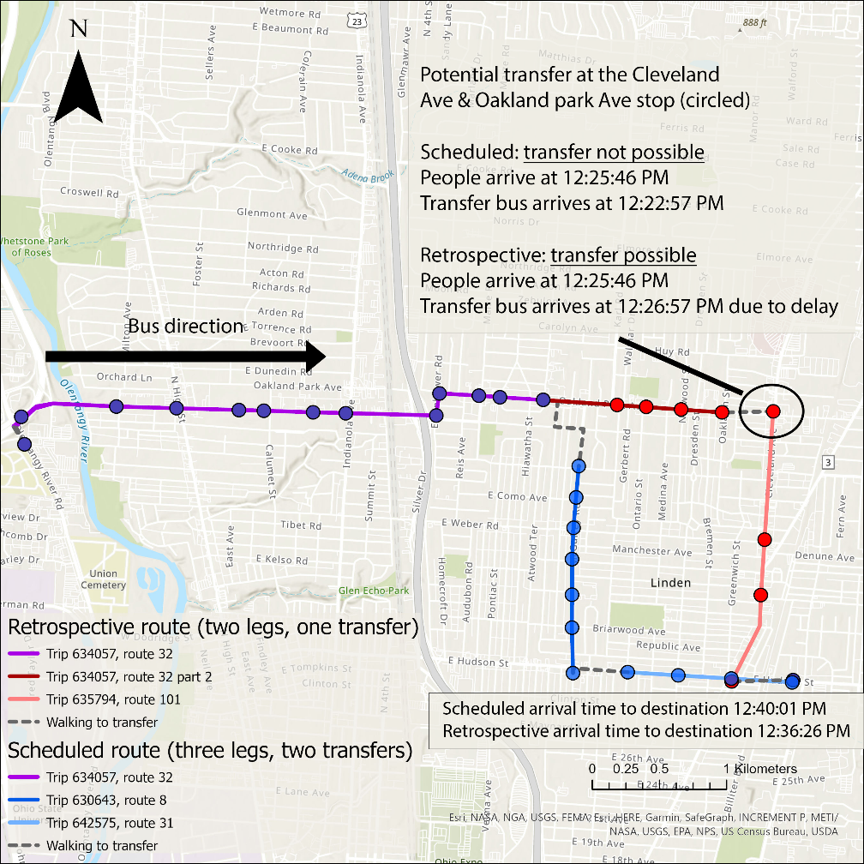

Figure 1: An example of overestimation in retrospective route (red, with 2 legs) compared to scheduled route (blue, with 3 legs). A delayed bus on the retrospective route’s second leg (pink, origin stop circled) makes the transfer feasible, which is impossible in the scheduled timetable and very hard for normal users to anticipate.

We can moreover deconstruct scheduled and retrospective real-time accessibility from a perspective of a user’s decision-making: these two accessibility systems do not separate the decision making and the decision implementation process. For a user, the decision-making process typically happens *before* the implementation process since people plan their trips before taking the transit, and the implementation result can be different from what they plan. However, both schedule and retrospective real-time accessibility models assume the two processes are happening simultaneously: the users are assumed to always realize the expected trip plan and never miss a bus. Such an assumption is unrealistic because users are likely to miss a bus and suffer additional time penalty in reality, especially during transfers when users have no control over the buses (Liu & Miller, 2020b; Park et al., 2020).

**Realizable real-time STP.** Because of the unrealizable nature of both schedule and retrospective real-time accessibility models, we therefore define *realizable real-time STP,* or more generally *realizable real-time accessibility,* based on realizable real-time shortest travel time between any stops. We calculate realizable real-time shortest travel time in two steps to better represent transit users’ actual decision-making process: *planning* and *implementation*.

The first step is *planning*. We calculate a hypothetical user’s trip plan from the scheduled timetable, including all the shortest travel time and the corresponding route choice assuming buses follow the schedule. We assume that users do not have access to real-time information (RTI) about public transit since we want to define realizable real-time accessibility as a conservative estimate of experienced accessibility. In addition, from a social equity perspective, RTI may not be accessible for everyone since smartphone and broadband Internet access are not universal (Mohadisdudis & Ali, 2014; Tsetsi & Rains, 2017).

The second step is *implementation*. The results of the planning step show how users or their trip planning app expect their trips will be, but the actual outcome can vary depending on the system’s actual on-time performance. Therefore, we revisit the same route choice plan from the planning step; we find the actual travel time between each arc and actual arrival time at each node on the planned route from the real-time transit data. This means the trajectories of scheduled and realizable real-time STP are the same, but they can have different travel times. For example, the trajectory is {A, B, C} in the trip plan between A and C, where A, B, C represent a sequence of stops. The user is scheduled to take bus 1 from stop A to B, then transfer at stop B to another bus 2, and finally arrive at stop C. However, because bus 1 is delayed, the user arrives late at the transfer stop B and misses the scheduled transfer bus 2. We then find the next bus from stop B to C and record the new arrival time at stop C and travel time between stop A and C. Note that the user will not follow alternative routes, since users plan their route fully based on the schedule and the freedom of switching routes during the trip is limited.

There are several factors that contribute to differences between the retrospective and realizable real-time STPs: i) unlike the retrospective accessibility, a user does not have to experience the trip itself to make the decision about the trip, and it is calculated from information that can be obtained before the trip happens. Therefore, it is *realizable*; ii) delayed or early arrival at the origin stop and transfer stops can result in substantial delay times for longer trips that involves multiple transfers; iii) routes calculated retrospectively can exploit shortcuts that result in reduced travel times compared to the scheduled routes as shown in Figure 1, however, real-world users cannot anticipate these shortcuts.

From the perspective of information veracity, we can consider retrospective accessibility as the measure that requires perfect RTI input for user decision-making, which can fully foretell the future states of the network. Conversely, we can consider realizable accessibility as the measure with no RTI input, which can not anticipate future states of the network. Therefore, we view the retrospective and realizable STP as the *upper bound* and *lower bound* of accessibility, respectively. Other accessibility measures with different RTI-based predicting schemes or routing algorithms should produce STPs that fall between the two benchmarks. For the same reason, although we use realizable real-time STP as a relaxed benchmark in this study, we do not claim the realizable measure can fully reflect all transit users’ behavior and can be a universally authoritative benchmark for all purposes. Many other routing algorithms adopt different assumptions and conditions, which almost guarantee their results will be different (further discussed in section 4.2).

Figure 2 illustrates six possible relationships among the three STPs. The realizable accessibility should always be the smallest of the three, while the retrospective accessibility can be equal to, larger than, or smaller than the scheduled accessibility depending on the network geometry and on-time performance.

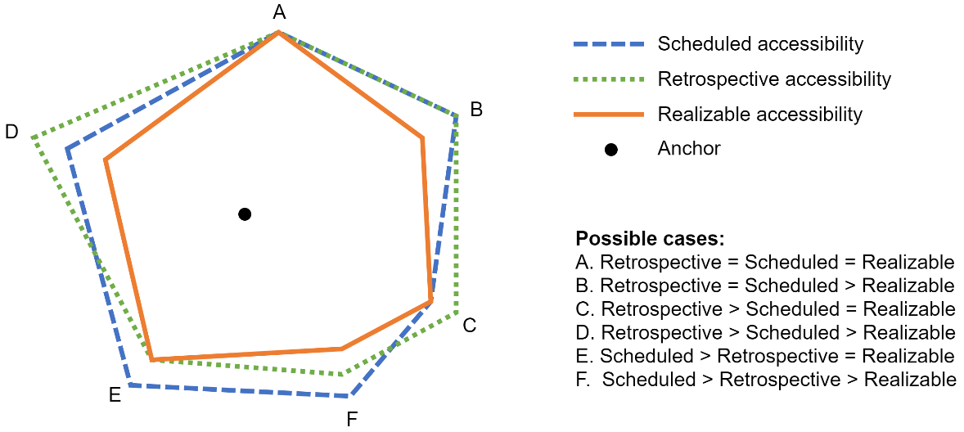

Figure 2: Possible relationships among the PPAs in the three STPs.

* 1. Accessibility unreliability

We define *accessibility unreliability* as the difference between expected (scheduled STP and retrospective real-time STP) and the delivered accessibility measures (realizable real-time STP)*.* Based on the STP definition provided in equation (3), we define accessibility unreliability as:

|  |  |  |
| --- | --- | --- |
|  |  | (4) |

where: $S_{i}^{ϕ}$ is the expected STP (schedule or retrospective) starting from a time point $ϕ$, $R_{i}^{ϕ}$ is the realizable STP, $s_{iτ}^{ϕ}$ is the expected number of accessible stops, and $r_{iτ}^{ϕ}$ is the realizable number of accessible stops. We calculate two versions of accessibility unreliability: scheduled STP’s unreliability and retrospective real-time STP’s unreliability. Scheduled STP is the promise that the transit authorities make to users, while the realizable STP is the actual experience the transit system delivers. The difference between the two represents the part of accessibility the transit system loses during operation compared with the schedule.

1. Analysis

In this section, we apply the methods above to empirical schedule and real-time data for the transit network in Columbus, Ohio. We first discuss the general differences between the scheduled, retrospective, and realizable STPs. We then show the spatial pattern of accessibility unreliability for different time budgets. Finally, we analyze the temporal pattern of accessibility unreliability in multiple dimensions.

* 1. Overall differences between three STPs

We first illustrate a specific scenario to demonstrate differences among the three STPs. Figure 3 shows an example of the PPAs corresponding to scheduled, retrospective, and realizable STPs with different time budgets from a bus stop in downtown Columbus at 8:00am on 4 September 2019. We can see that the schedule and retrospective PPAs resemble each other spatially, while the realizable STP is more circumscribed. Figure 3 (lower right quadrant) overlays the three STPs’ PPAs for a time budget of 30 minutes (also highlighted in other three maps in Figure 3) at the same origin stop and the same time. This illustrates that schedule and retrospective accessibility may be different from each other in terms of their spatial footprint, but they are nevertheless a generous delimitation of accessibility compared to the more conservative realizable STP.

Figure 4 shows the global average trend of the three measures. The plot shows the number of accessible stops as a function of the time budget. The plot clearly shows how the realizable measure is consistently smaller and a more conservative estimate of accessibility than the other two. Another notable observation is that the retrospective and schedule measures are similar, and the retrospective measure is sometimes greater and sometimes smaller than the schedule measure. This phenomenon illustrates that if a user is given perfect real-time information in a way that they can fully predict the future, the user can achieve comparable accessibility to that promised by the schedule and can even exceed it in some cases despite the existence of system delay. However, it is impossible to get perfect predictive real-time information in practice. The similarity of retrospective and scheduled measures may seem counterintuitive based on the dissimilarity of the two measures in Figure 3, however it should be noted that that Figure 4 represents the average of the STPs for all stops while Figure 3 shows the STP for only one stop.

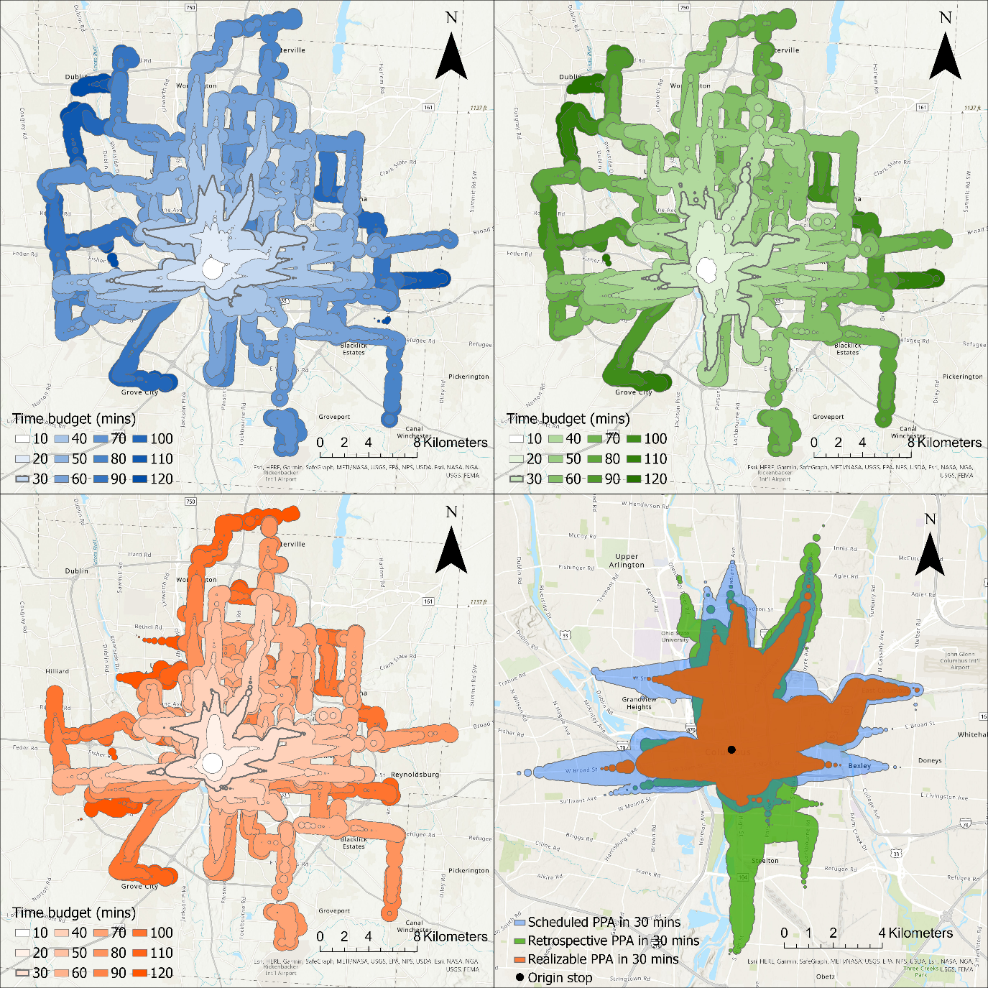

Figure 3: examples of scheduled (top left), retrospective (top right), and realizable STPs (bottom left) from a bus stop in the central downtown Columbus (North High Street & West Broad Street) at 8:00am, Sep 4, 2019, and overlaying PPAs (highlighted) for the time budget of 30 minutes from the three STPs (bottom right).

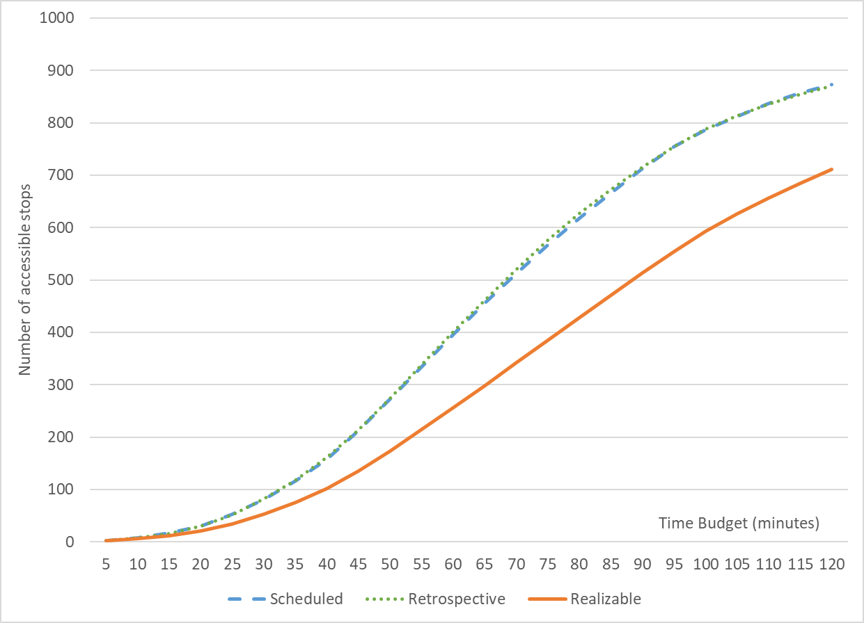

Figure 4: global average number of accessible stops for all stops in the COTA system.

* 1. Spatial pattern of accessibility unreliability

**Schedule-based accessibility with respect to the realizable.** We present results from analyzing the unreliability of schedule-based accessibility, using the realizable accessibility measure as a benchmark (equation 4). Figure 5 shows four maps of schedule-based implicit STP’s unreliability with respect to the realizable measure for each stop for time budget of 15, 30, 60, 90 minutes for the last four months in 2019. Note that the map does not visualize a single STP; instead, the map summarizes more than 3000 STPs to their corresponding anchor (i.e., origin bus stop), showing the unreliability of each STP originating from each stop.

We can see from the maps that the spatial pattern of accessibility unreliability is highly dependent on the time budget: for smaller budget of 15 minutes, unreliability concentrates on the city center; for bigger and more practical time budgets for longer trips of 30 – 60 minutes, unreliability gradually spreads to a larger area until it affects almost all stops in the system. For relatively large time budgets, unreliability of schedule-based accessibility starts to decrease from the center and becomes more concentrated in the periphery. We call this phenomenon *saturation*. As the PPA expands to include the whole system with larger time budgets, the scheduled PPA component in equation (4) will not be larger since the system has finite number of bus stops and it reaches a maximum value; however, the realizable PPA item will continue to rise, making the unreliability index smaller. Similar phenomena have been observed in prior studies (Wessel & Farber, 2019).

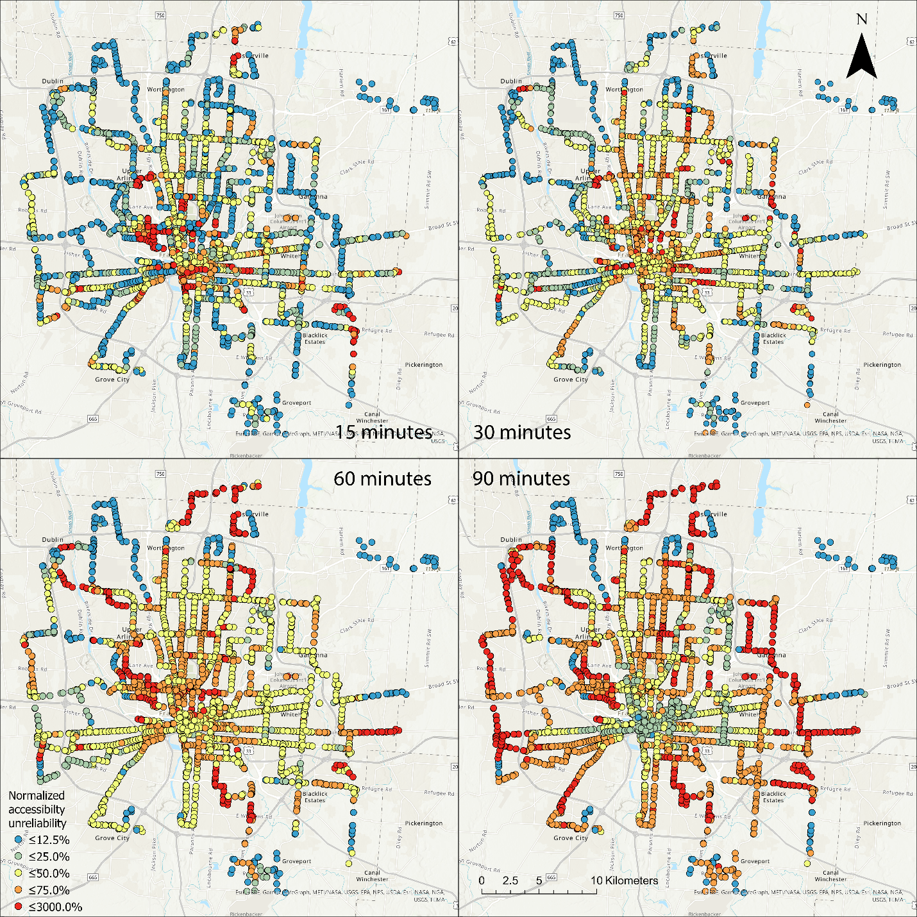

Figure 5: maps of unreliability for schedule-based accessibility with respect to the realizable measure for each stop for time budget of 15, 30, 60, 90 minutes for the last four months in 2019.

Figure 6 depicts the average scheduled-based unreliability as a function of time budget for four classes of stations based on their distance to the city center (downtown core, and inner, middle and outer rings) and also the global average. The saturation process is evident; all curves first increase and reach a peak, then decrease as the time budget becomes large enough for schedule-based accessibility to include the entire network. However, depending on the geographic location of the stop, the time budget for peak unreliability will be different: the time budget where the peak occurs is directly correlated with the distance of the stops from the city center. This supports the pattern observed in Figure 5 in which the high unreliability cluster migrates outward from the city center as time budget increases. We speculate that this phenomenon may be due to the star-shaped route alignment and transfer-focus planning strategy of the COTA bus system, since most unreliability comes from time penalty of missing a transfer (Liu & Miller, 2020b, 2020a). Moreover, as longer trips require more than one transfer, the total transfer time penalty will be larger due to a chain reaction effect.

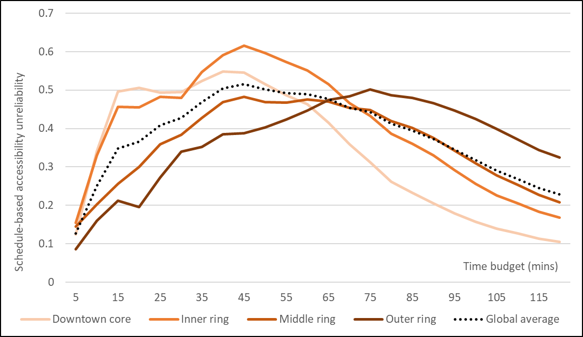

Figure 6: schedule-based accessibility unreliability for downtown core (radius of 2000 meter from downtown center), inner ring (radius of 2000 - 5000 meters), middle ring (radius of 5000 – 10000 meters), outer ring (outside 10000 meters) for the last four months in 2019.

It is noteworthy that our conclusions in the two sections above are seemingly different from the findings in Wessel et al. (2017) and Wessel & Farber (2019) despite using a similar cumulative opportunities approach to measure accessibility. There are several explanations for this contradiction: 1) the realizable accessibility measure is essentially a different measure from the retrospective accessibility used in those studies; 2) we use a different routing algorithm; 3) Wessel et al. (2017) observed that their retrospective measure was similar to schedule-based accessibility on average, which is consistent with our findings; 4) Wessel & Farber (2019) only select one specific long time budget (cumulative parameter) for geographic visualizations, while we present results with multiple time budgets. In fact, the unreliability pattern for the 90-minute time budget in Figure 5 is very consistent with prior findings (Wessel & Farber, 2019), which suggests the existence of saturation in those systems; 5) The COTA system is a very geographically large and sparse bus system, and the peak unreliability occurs at a time budget of around 45 minutes as shown in Figure 6. In other cities such as Toronto and San Francisco, peak unreliability occurs at a time budget of less than 30 minutes (Wessel & Farber, 2019). This means that it takes users in Columbus much longer to travel to the edge of the system, and the unreliability requires a longer time budget to reach saturation.

* 1. Temporal patterns

We now turn to temporal patterns in schedule-based unreliability. We conducted temporal analysis on several dimensions in terms of the start time: daily, days of week, and hours.

**Daily.** Figure 7 shows the daily pattern of the normalized accessibility unreliability from 2018 to 2019. Because larger time budgets have less volatile patterns due to saturation, we only include the results for time budgets of 5 to 60 minutes. Time budgets larger than 15 minutes show generally similar and higher-variance patterns, while smaller time budgets have patterns exhibiting lower variance. We observe similar patterns in the spatial analysis (e.g., global average trend in Figure 6) and other temporal analyses (e.g., hourly pattern). We can observe two spikes among different months: February and September to October. We speculate this may be linked to the seasonal schedule adjustments in January, May, and September every year, as operators need time to adjust to the new schedule leading to higher unreliability.

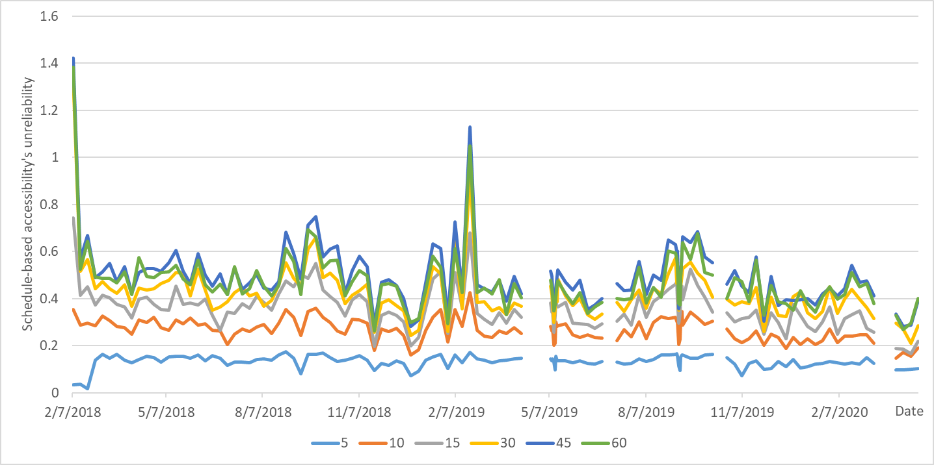

Figure 7: daily average unreliability for schedule-based accessibility for time budgets of 5 to 60 minutes. Gaps indicate missing data.

**Days of the week.** Figure 8 shows the average normalized schedule-based accessibility unreliability for each day of the week for the week of Sep 4, 2019, at 8am for time budgets ranging from 5 to 60 minutes. We selected this week because it is during the most recent four months in the analysis period and has a typical level of unreliability compared to other weeks from the daily analysis in Figure 7. The pattern shows that Wednesday, Friday, and Tuesday have the highest unreliability, while Monday, Saturday, and Sunday have the lowest unreliability. This pattern is consistent with prior findings about delay (Park et al., 2020) and risk of missing transfers (Liu & Miller, 2020b) in the COTA bus system, which shows the inherent connections of accessibility unreliability to delay and transfer time penalty.

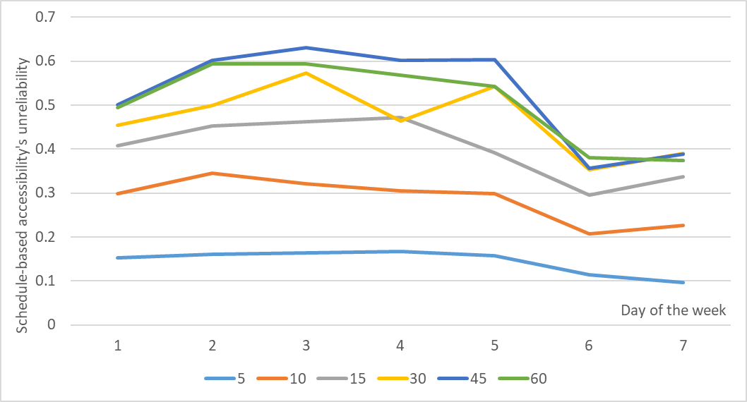

Figure 8: unreliability of schedule-based accessibility with respect to realizable accessibility for each day of week for the week of September 4, 2019.

**Hourly.** Figure 9 presents the hourly pattern for schedule-based accessibility – i.e., the unreliability on the hour from 6:00 to 23:00 on Sep 4, 2019. We chose the day as a typical day for the same rationale described previously: the daily analysis shows that unreliability on this day is neither too high nor too low. The unreliability varies little throughout the day. The highest unreliability generally occurs during the morning rush hour (8:00) and the afternoon rush hour (18:00), which is also consistent with the hourly pattern of delay (Park et al., 2020) and risk of missing transfers (Liu & Miller, 2020b). The hourly variation becomes less obvious for very small time budget (such as 5 minutes), which is also consistent with the analysis above.

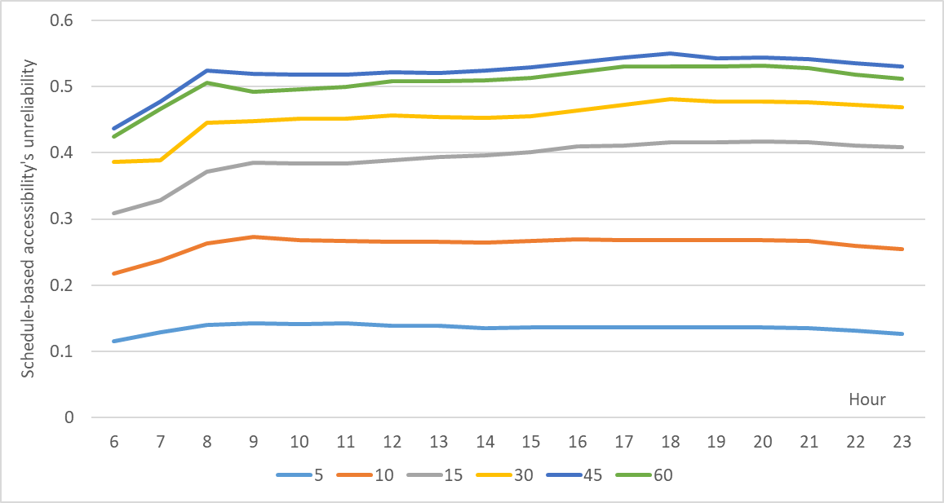

Figure 9: unreliability of schedule-based accessibility with respect to the realizable accessibility as a function of start times for time budgets of 5, 15, 30, 45, and 60 minutes on September 4, 2019.

1. Conclusion

Measuring transit user’s accessibility is a crucial part of public transit research and a prerequisite of transit planning and policy making. Among numerous accessibility measures, the space-time prism (STP) is an especially effective method for measuring the physical accessible area afforded by the system for transit users; as more real-time data become available, the size and fidelity of the analysis can increase correspondingly. However, traditional measures still largely rely on scheduled data, which cannot reflect the variation of the transit system’s on-time performance (Wessel et al., 2017; Wessel & Farber, 2019). Some prior studies used retrospective real-time methods to calculate accessibility using data, however these measures assume transit users know future arrival times *a priori* (Wessel & Farber, 2019) and never miss a bus, thus overestimating the ability of users to obtain information and reach destinations. This paper introduces a new time geography approach – *realizable real-time space-time prism* – to address the limitations of schedule-based and retrospective real-time measures and incorporate transit users’ capabilities in the calculation of accessibility. The realizable STP is novel in that it is a two-step method that accounts for both the decision-making and implementation processes of a user. We moreover introduce *accessibility unreliability* as the normalized difference between schedule-based or retrospective-based measure and the realizable measure. Thus, unreliability quantifies degree to which traditional measures overestimate accessibility. Put another way, unreliability quantifies the difference between a transit system’s expected performance and its realized performance in terms of accessibility.

This paper provides findings that can make accessibility more practical for transit users, planners, and authorities. We use high-resolution real-time General Transit Feed Specification (GTFS) data and a time-dependent routing algorithm to implement the proposed methods for the Central Ohio Transit Authority (COTA) bus system in Columbus, Ohio, USA. Our analyses show that the potential path area of realizable accessibility is always the smallest compared to the other two measures and cannot cover all the COTA system even given a large (two hour) time budget. Therefore, the realizable STP is a different, more conservative measure compared to its scheduled and retrospective counterparts. We also find the global average performance of scheduled and retrospective accessibility are very similar. We then explore the spatial pattern of schedule-based accessibility unreliability and its relationship with time budget. As a function of time budget, high unreliability tends to spread from the city center to the suburban fringe as time budget increases, but is followed by a pattern of low unreliability spreading from the center as time budget continues to increase. This is due to a saturation effect conciding with very large time budgets that occurs when schedule- or retrospective-based measures reach all the stops possible in a finite system. Our temporal analyses demonstrate that unreliability for schedule-based accessibility is higher in February and September, morning and afternoon rush hours, and the middle of the week. This is consistent with prior findings related to bus delays (Park et al., 2020) and the risk of missing transfers (Liu & Miller, 2020b), indicating the inherent connections between these phenomena and unreliability.

The realizable STP can be a more user-centric and conservative measure for future transit planning and operation, and its pattern shows the asymmetric reality of transit planning: many transit systems set a very high standard for transit users and operators (e.g., trips involving two or three transfers with very high uncertainties), however this expectation cannot be delivered to transit users by operators (e.g., missing buses and wait for the next bus for hours). Meanwhile, if schedule data are used as the sole data source for planning outcome measurement, the unreliability issues may never be addressed during the planning process due to lack of awareness. As transit authorities aim to enhance accessibility from the system’s perspective, it is equally important to consider the reality from a user’s perspective, i.e., whether a user can finish the trips in the real world. This requires greater use of real-time analysis and big data with larger volume and faster velocity during the transit planning process in the future. If planning continues to be based on schedule alone, it is imperative for authorities and planners to consider the inherent unreliability of scheduled and retrospective measures and plan more conservatively.

There are several topics that remain unexplored in this paper. First, our analysis only allows for *following the schedule* as a user’s trip planning strategy, which cannot be universally applied to every transit user. As real-time information (RTI) becomes more accessible, more advanced real-time prediction algorithms can significantly enhance the experience of a user. Rather than attempting to account for the continuum of possible RTI integration, we provide the retrospective measure as the upper bound (perfect RTI) and the realizable measure as the lower bound (no RTI) for use as benchmarks. Second, despite incorporating users’ cognitive factors in the calculation, the paper’s scope is still within the physical accessibility afforded by the system and there are no behavioral data to moreover reaffirm the findings, such as how the measured unreliability impacts actual user’s transit experience or overall ridership. Future studies can survey transit users’ perceived accessibility and compare the results with the three introduced measures to investigate the impact of unreliability on the demand side. Third, this paper is based on a rigorous, time-dependent Dijkstra routing algorithm, and results based on this algorithm may differ from other mainstream routing algorithms (e.g., Open Trip Planner) which likely use heuristics for scalability. However, although each algorithm can have its own specific implementation, it is indeed a universal risk for retrospective-based algorithms to make the overestimation mistakes discussed in this paper. Last, the empirical results derived from the COTA system may not be able to be applied to other systems; we hope future studies can conduct similar analysis on other transit systems and explore the relationship between unreliability and different aspects of system network topology, such as route alignment, stop locations, and headways.

Statements and declarations: None

References:

Ahn, B.-H., & Shin, J.-Y. (1991). Vehicle-routeing with time windows and time-varying congestion. *Journal of the Operational Research Society*, *42*(5), 393–400.

Arbex, R., & Cunha, C. B. (2020). Estimating the influence of crowding and travel time variability on accessibility to jobs in a large public transport network using smart card big data. *Journal of Transport Geography*, *85*, 102671.

Banister, D. (2008). The sustainable mobility paradigm. *Transport Policy*, *15*(2), 73–80.

Barbeau, S. J., & Antrim, A. (2013). The Many Uses of GTFS Data – Opening the Door to Transit and Multimodal Applications. In *ITS America 2013*. Nashville, Tennessee: Intelligent Transportation Society of America. Retrieved from http://prezi.com/-69luw8sfabp/the-many-uses-of-gtfs-data-its-america-april-2013/

Batty, M. (2013). Big data, smart cities and city planning. *Dialogues in Human Geography*, *3*(3), 274–279.

Burns, L. D. (1980). Transportation, temporal, and spatial components of accessibility.

Central Ohio Transit Authority. (2021). Data. Retrieved June 27, 2021, from https://www.cota.com/data/

Chen, B. Y., Li, Q., Wang, D., Shaw, S.-L., Lam, W. H. K., Yuan, H., & Fang, Z. (2013). Reliable space–time prisms under travel time uncertainty. *Annals of the Association of American Geographers*, *103*(6), 1502–1521.

Chen, B. Y., Yuan, H., Li, Q., Shaw, S.-L., Lam, W. H. K., & Chen, X. (2016). Spatiotemporal data model for network time geographic analysis in the era of big data. *International Journal of Geographical Information Science*, *30*(6), 1041–1071.

Delafontaine, M., Neutens, T., & Van de Weghe, N. (2011). Modelling potential movement in constrained travel environments using rough space–time prisms. *International Journal of Geographical Information Science*, *25*(9), 1389–1411.

Fang, Z., Shaw, S.-L., Tu, W., Li, Q., & Li, Y. (2012). Spatiotemporal analysis of critical transportation links based on time geographic concepts: a case study of critical bridges in Wuhan, China. *Journal of Transport Geography*, *23*, 44–59.

Farber, S., Bartholomew, K., Li, X., Páez, A., & Habib, K. M. N. (2014). Assessing social equity in distance based transit fares using a model of travel behavior. *Transportation Research Part A: Policy and Practice*, *67*, 291–303.

Farber, S., O’Kelly, M., Miller, H. J., & Neutens, T. (2015). Measuring segregation using patterns of daily travel behavior: A social interaction based model of exposure. *Journal of Transport Geography*, *49*, 26–38.

Gendreau, M., Ghiani, G., & Guerriero, E. (2015). Time-dependent routing problems: A review. *Computers & Operations Research*, *64*, 189–197.

Golden, B. (1976). Shortest-path algorithms: A comparison. *Operations Research*, *24*(6), 1164–1168.

Google Developers. (2020). GTFS Static Overview | Static Transit | Google Developers. Retrieved May 26, 2021, from https://developers.google.com/transit/gtfs/

Hägerstrand, T. (1970). What about people in regional.

Hall, R. W. (1983). Travel outcome and performance: the effect of uncertainty on accessibility. *Transportation Research Part B: Methodological*, *17*(4), 275–290.

Handy, S. (2020). Is accessibility an idea whose time has finally come? *Transportation Research Part D: Transport and Environment*, *83*, 102319.

Hansen, W. G. (1959). How accessibility shapes land use. *Journal of the American Institute of Planners*, *25*(2), 73–76.

Hsiao, S., Lu, J., Sterling, J., & Weatherford, M. (1997). Use of geographic information system for analysis of transit pedestrian access. *Transportation Research Record*, *1604*(1), 50–59.

Ichoua, S., Gendreau, M., & Potvin, J.-Y. (2003). Vehicle dispatching with time-dependent travel times. *European Journal of Operational Research*, *144*(2), 379–396.

Ingram, D. R. (1971). The concept of accessibility: a search for an operational form. *Regional Studies*, *5*(2), 101–107.

Kim, H., & Song, Y. (2018). An integrated measure of accessibility and reliability of mass transit systems. *Transportation*, *45*(4), 1075–1100.

Lee, J., & Miller, H. J. (2018). Measuring the impacts of new public transit services on space-time accessibility: An analysis of transit system redesign and new bus rapid transit in Columbus, Ohio, USA. *Applied Geography*, *93*, 47–63. https://doi.org/10.1016/j.apgeog.2018.02.012

Lenntorp, B. (1976). Paths in space-time environments: a time-geographic sudy of movement possibilities of individuals. *Lund Studies in Geography B,* *44*, 150p.

Levinson, D., & Wu, H. (2020). Towards a general theory of access. *Journal of Transport and Land Use*, *13*(1), 129–158.

Li, X., & Farber, S. (2016). Spatial representation in the social interaction potential metric: an analysis of scale and parameter sensitivity. *Journal of Geographical Systems*, *18*(4), 331–357.

Liu, L., & Miller, H. J. (2020a). Does real-time transit information reduce waiting time? An empirical analysis. *Transportation Research Part A: Policy and Practice*, *141*, 167–179.

Liu, L., & Miller, H. J. (2020b). Measuring risk of missing transfers in public transit systems using high-resolution schedule and real-time bus location data. *Urban Studies*, 0042098020919323. https://doi.org/10.1177/0042098020919323

Liu, L., Miller, H. J., & Scheff, J. (2020). The impacts of COVID-19 pandemic on public transit demand in the United States. *PLoS ONE*, *15*(11 November), e0242476. https://doi.org/10.1371/journal.pone.0242476

Malekzadeh, A., & Chung, E. (2020). A review of transit accessibility models: Challenges in developing transit accessibility models. *International Journal of Sustainable Transportation*, *14*(10), 733–748.

Miller, H. J. (1991). Modelling accessibility using space-time prism concepts within geographical information systems. *International Journal of Geographical Information System*, *5*(3), 287–301.

Miller, H. J. (1999). Measuring space‐time accessibility benefits within transportation networks: Basic theory and computational procedures. *Geographical Analysis*, *31*(1), 187–212.

Miller, H. J. (2017). Time geography and space-time prism. *International Encyclopedia of Geography: People, the Earth, Environment and Technology*, 1–19.

Mohadisdudis, H. M., & Ali, N. M. (2014). A study of smartphone usage and barriers among the elderly. In *2014 3rd International Conference on User Science and Engineering (i-USEr)* (pp. 109–114). IEEE.

Neutens, T., Witlox, F., & Demaeyer, P. (2007). Individual accessibility and travel possibilities: A literature review on time geography. *European Journal of Transport and Infrastructure Research*, *7*(4).

O’Sullivan, D., Morrison, A., & Shearer, J. (2000). Using desktop GIS for the investigation of accessibility by public transport: an isochrone approach. *International Journal of Geographical Information Science*, *14*(1), 85–104.

Owen, A., & Levinson, D. M. (2015). Modeling the commute mode share of transit using continuous accessibility to jobs. *Transportation Research Part A: Policy and Practice*, *74*, 110–122.

Park, Y., Mount, J., Liu, L., Xiao, N., & Miller, H. J. (2020). Assessing public transit performance using real-time data: spatiotemporal patterns of bus operation delays in Columbus, Ohio, USA. *International Journal of Geographical Information Science*, *34*(2), 367–392. https://doi.org/10.1080/13658816.2019.1608997

Schmitt, A. (2018). The Columbus Bus Network Redesign Boosted Ridership. Retrieved June 29, 2021, from https://usa.streetsblog.org/2018/08/14/the-columbus-bus-network-redesign-boosted-ridership/

Tasic, I., Zhou, X., & Zlatkovic, M. (2014). Use of spatiotemporal constraints to quantify transit accessibility: Case study of potential transit-oriented development in West Valley City, Utah. *Transportation Research Record*, *2417*(1), 130–138.

Tribby, C. P., & Zandbergen, P. A. (2012). High-resolution spatio-temporal modeling of public transit accessibility. *Applied Geography*, *34*, 345–355.

Tsetsi, E., & Rains, S. A. (2017). Smartphone Internet access and use: Extending the digital divide and usage gap. *Mobile Media & Communication*, *5*(3), 239–255.

Wang, Y., Yuan, Y., Ma, Y., & Wang, G. (2019). Time-dependent graphs: Definitions, applications, and algorithms. *Data Science and Engineering*, *4*(4), 352–366.

Wessel, N., Allen, J., & Farber, S. (2017). Constructing a routable retrospective transit timetable from a real-time vehicle location feed and GTFS. *Journal of Transport Geography*, *62*, 92–97.

Wessel, N., & Farber, S. (2019). On the accuracy of schedule-based GTFS for measuring accessibility. *Journal of Transport and Land Use*, *12*(1), 475–500.

Widener, M. J., Farber, S., Neutens, T., & Horner, M. (2015). Spatiotemporal accessibility to supermarkets using public transit: an interaction potential approach in Cincinnati, Ohio. *Journal of Transport Geography*, *42*, 72–83.

Wu, H., & Levinson, D. (2020). Unifying access. *Transportation Research Part D: Transport and Environment*, *83*, 102355.

Wu, Y.-H., & Miller, H. J. (2001). Computational tools for measuring space-time accessibility within dynamic flow transportation networks. *Journal of Transportation and Statistics*, *4*(2/3), 1–14.

Xie, D., Zhu, H., Yan, L., Yuan, S., & Zhang, J. (2012). An improved Dijkstra algorithm in GIS application. In *World Automation Congress 2012* (pp. 167–169). IEEE.

Zhang, T., Dong, S., Zeng, Z., & Li, J. (2018). Quantifying multi-modal public transit accessibility for large metropolitan areas: a time-dependent reliability modeling approach. *International Journal of Geographical Information Science*, *32*(8), 1649–1676.

Zhao, F., Chow, L.-F., Li, M.-T., Ubaka, I., & Gan, A. (2003). Forecasting transit walk accessibility: Regression model alternative to buffer method. *Transportation Research Record*, *1835*(1), 34–41.

1. * Corresponding author, email: miller.81@osu.edu

   ORCID: Luyu Liu (0000-0002-6684-5570), Adam Porr (0000-0002-4776-5575), Harvey J. Miller (0000-0001-5480-3421)